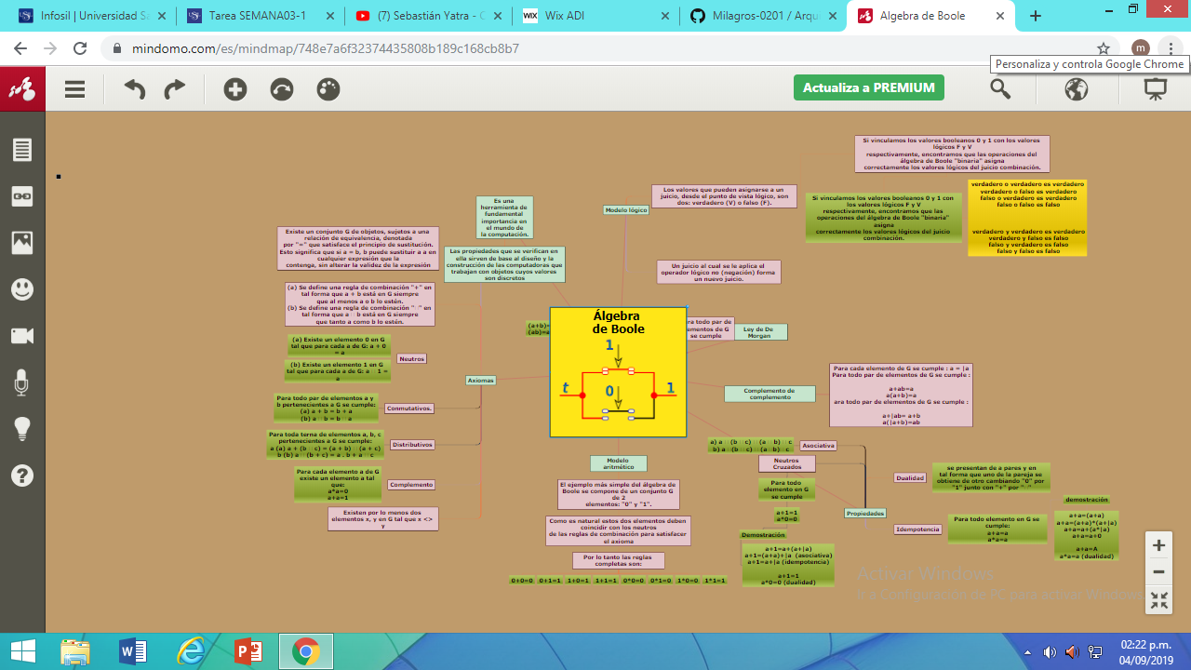**Álgebra de Boole**

Link de wix:

<https://milagrosyeseniasan.wixsite.com/website>